NAME: AKINBODE OLAJUMOKE ADESOLA
DEPARTMENT: NURSING SCIENCE
MATRIC NUMBER: 18/SCI05/002
COURSE TITLE: PHYSIOLOGY
COURSE CODE: PHS 212
EYE DEFECTS
- MYOPIA or NEARSHIGHTED
Myopia occurs when the eyeball is too long, relative to the focusing power of the cornea and lens of the eye. It affects about one third of people. People with myopia can see nearby objects clearly, but distant objects appear blurry. This causes light rays to focus at a point in front of the retina, rather than directly on its surface If you're near-sighted, the first number ("sphere") on your eyeglasses prescription will be preceded by a minus sign (–). The higher the number, the more near-sighted you are. In myopia, the eye is too long, Myopia is corrected with a concave lens, which curves inward like the inside of a bowl. The lens changes the focus, so images fall on the retina as they should.

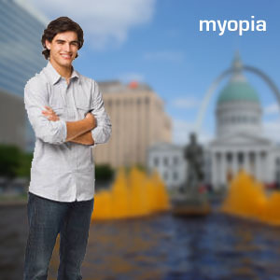
The picture below shows how a person with myopia might see two boys that are a few meters away (figure below).
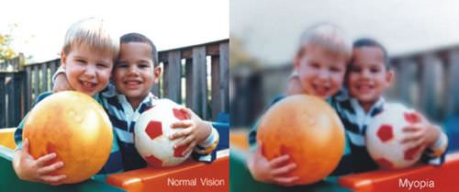

On the left, you can see how a person with normal vision sees two boys. The right image shows how a person with myopia sees the boys.

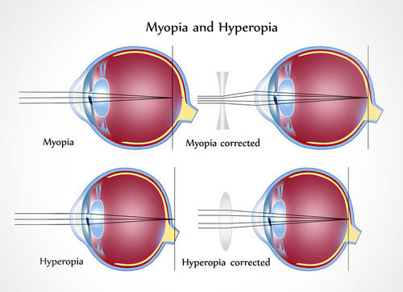
The eye of a person with myopia is longer than normal. As a result, images are focused in front of the retina (top left). A concave lens is used to correct myopia to help focus images on the retina (top right). Farsightedness, or hyperopia, occurs when objects are focused in back of the retina (bottom left). It is corrected with a convex lens (bottom right).

- HYPEROPIA or FARESIGHTED
This vision problem occurs when light rays entering the eye focus behind the retina, rather than directly on it. The eyeball of a farsighted person is shorter than normal. Farsightedness can be corrected with glasses to change the way light rays bend into the eyes. If your glasses begins with plus numbers, like +1.50, you are farsighted. It affects about one fourth of people. People with hyperopia can see distant objects clearly, but nearby objects appear blurry. In hyperopia, the eye is too short. This results in images being focused in back of the retina (Figure above). Hyperopia is corrected with a convex lens, which curves outward like the outside of a bowl. The lens changes the focus so that images fall on the retina as they should. Common signs of farsightedness include difficulty in concentrating and maintaining a clear focus on close objects, eye strain, fatigue and headaches after close work, and aching or burning eyes, especially after intense concentration on close work. In addition to lenses, many cases of myopia and hyperopia can be corrected with surgery. For example, a procedure called LASIK (Laser-Assisted in situ Keratomileusis) uses a laser to permanently change the shape of the cornea so light is correctly focused on the retina.

